By expanding the concept of size mixtures, we conducted a series of numerical simulations and found the composition of the optimal bimodal distribution. As seen in Figure 1, the optimal range would include fine particle concentration between 33% to 67% with its mean size between 20% to 30% of fracture outlet width. The coarse particle mean size should be 90% of fracture outlet width. Additionally, the dimensionless Ruark number is sued to indicate the plugging of LCMs inside a fracture as seen in Figure 2. The Ruark number is the differential pressure over fluid density and fluid velocity squared.
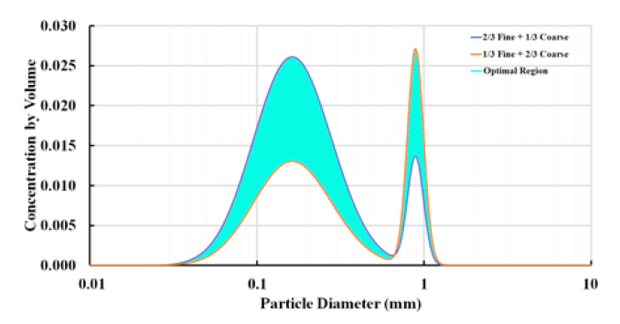
Figure 1: Optimal LCM designs under bimodal distributions.
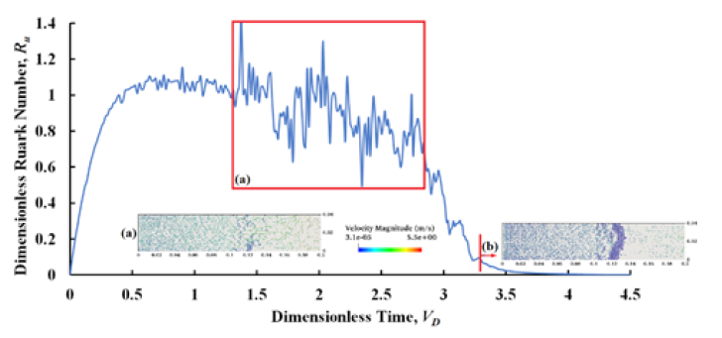
Figure 2: The dimensionless Ruark number vs dimensionless time for D/Wf = 0.5.

